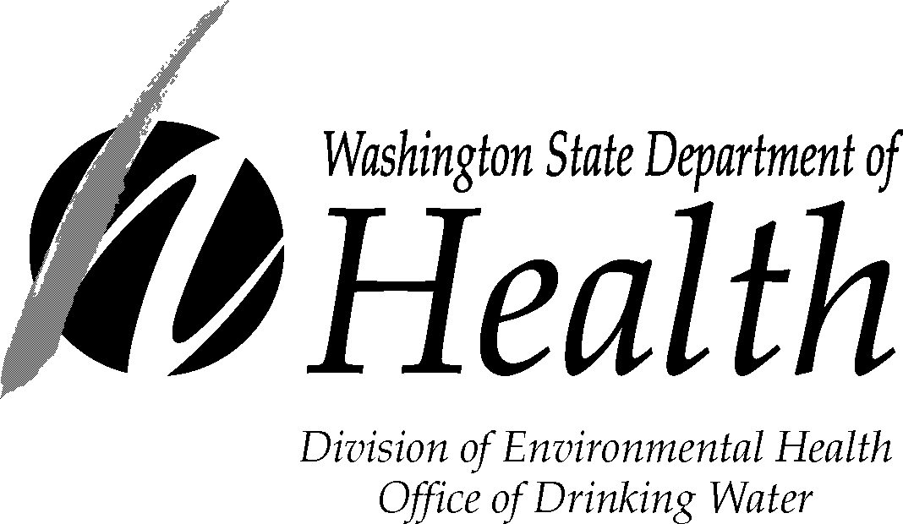
PUBLIC NOTICE CERTIFICATION
E. coli-MCL Violation

Within 10 days after notifying your customers about an E. coli-MCL violation, you must complete this form and send it to our regional office along with a copy of each type of notice you distributed to your customers (hand-delivered notices, news releases, newspaper articles, and so on).

By completing this form, you certify that:
- You met all of the public notification requirements.
- You will meet future requirements for notifying new billing units of the violation or situation.

If the boil water advisory remains in effect more than three months, you must re-notify your water users and send another completed copy of this Public Notice Certification to us.

Complete the following items, sign the form and mail it to the nearest regional office, addresses below:

Water System: ID # County:

Violation Date: / / Violation Type

This public water system certifies that it gave this public notice to water users, following state and federal requirements for delivery, content, and deadlines. | Yes  No

Distribution was completed Yes No on / / .

Check all that apply:
Hand delivery,
News release (TV, radio, newspaper)
Posting at (by DOH approval only),
Other (by DOH approval only).

Were the water users notified within 24 hours? Yes No

Signature of owner or operator Position Date

If you need this publication in an alternative format, call 800.525.0127 (TDD/TTY call 711). This and other publications are available at www.doh.wa.gov/drinkingwater.

Northwest Regional Office:
20425 72nd Ave S Suite 310
Kent WA 98032
(253) 395-6775
Fax: (253) 395-6760
Email: dw.nwro@doh.wa.gov
Southwest Regional Office:
PO Box 47823
Olympia WA 98504-7823
(360) 236-3030
Fax (360) 664-8058
Email: swro.coli@doh.wa.gov
Eastern Regional Office:
16201 E Indiana Ave Suite 1500
Spokane Valley WA 99216
(509) 329-2100
Fax: (509) 329-2104
Email: mark.steward@doh.wa.gov

