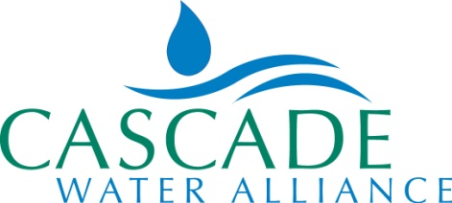
Eurasian Water Milfoil
Frequently Asked Questions

Does Cascade have a legal obligation to control milfoil?

No, Cascade has no regulatory obligation to control milfoil or other aquatic plants in the Lake Tapps reservoir except for regulated noxious weeds. The Pierce County Noxious Weed Board no longer lists milfoil as a regulated noxious weed (http://piercecountyweedboard.org/index.php/watermilfoil).

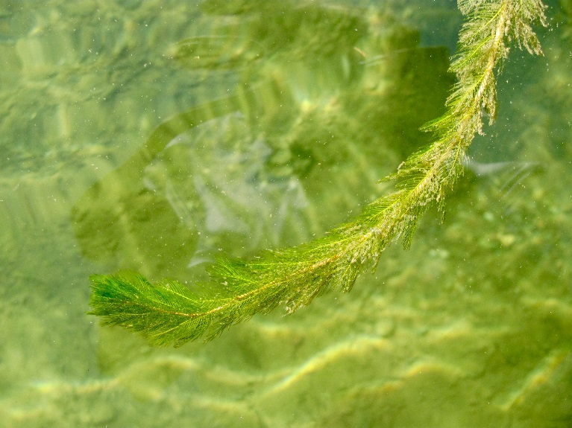
What does Cascade do about milfoil?

Since 2010, Cascade has aggressively surveyed and treated milfoil. The Lake Tapps Reservoir is assessed annually to determine areas in greatest need of treatment. Cascade currently has all necessary permits to control milfoil under the 10-year Cascade 2015 Integrated Aquatic Vegetation Management Plan. Below is a summary of Cascade’s efforts to manage milfoil; for more details, see www.cascadewater.org/milfoil.

- Chemical Treatment: Since 2010, Cascade has primarily managed milfoil growth with chemical treatments. Cascade has used the herbicide ProcellaCOR for treatment since 2019.
- TappsWise Program: Since nutrients from lawns and septic tanks significantly increase vegetation, Cascade has initiated the TappsWise program (www.tpchd.org/TappsWise), a partnership with Tacoma-Pierce County Department of Health, to promote natural yard care and septic maintenance to keep Lake Tapps clean and healthy.
- Pilot Studies: Cascade conducted two pilot studies in 2018 and 2019 on controlling milfoil with bottom barriers and dry-land herbicide treatments. Neither pilot project was successful in controlling milfoil.
- Research Support: There are multiple strains of milfoil, some resistant to herbicides. Cascade hired a research team to sample and identify the various genotypes in the reservoir and eleven strains were found. Cascade also supported Washington State’s approval of use of a new herbicide, ProcellaCOR.

What can homeowners do about milfoil?

To remove aquatic plants from Lake Tapps in front of their property, by hand, using bottom-barriers, or otherwise, homeowners must follow rules outlined in Washington Department of Fish and Wildlife’s “Aquatic Plants and Fish: Rules for Aquatic Plant Removal and Control” at https://wdfw.wa.gov/publications/01728. Homeowners must also obtain any necessary permits from appropriate agencies, such as Bonney Lake and Pierce County.

Nutrients from lawns and septic tanks significantly increase vegetation, so reducing fertilizer applications and keeping septic tanks maintained and working properly will reduce growth. Residents are encouraged to participate in the TappsWise program at www.tpchd.org/TappsWise. For more detailed information on what homeowners can do about milfoil visit www.cascadewater.org/milfoil.
Homeowners are not permitted to treat milfoil with herbicides; only Cascade, as owner of the reservoir, holds a permit for treatment.

What causes milfoil to grow?

There are many factors that impact milfoil growth. Fertilizers from lawns, septic drain fields, waterfowl droppings, water levels and sunlight all contribute to growth. Milfoil can also be brought to the Lake Tapps reservoir from other water bodies by boats. Milfoil growth varies year to year depending on all these factors.

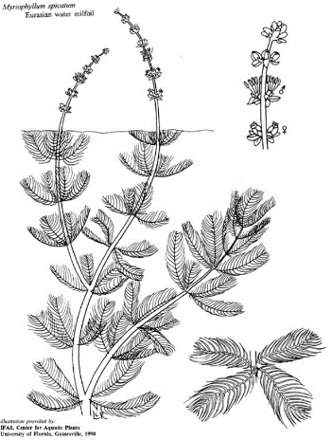
Cascade operates the reservoir differently than Puget Sound Energy. Does that alter its regulatory obligations to control noxious weeds?

No, regulatory obligations are not altered due to different operations.

Cascade is required to control the water flow through the reservoir according to water rights approved by the State Department of Ecology. Does water flow impact milfoil?

Yes, to some extent, although there are many factors that cause milfoil to grow. Reduced water flow has decreased the turbidity of the water, so it is clearer than when Puget Sound Energy operated the reservoir. This clarity increases both nutrients and sunlight that reaches places that are more likely to support plant growth. However, milfoil was also present when Puget Sound Energy operated Lake Tapps reservoir at higher flows.

Will lowering the reservoir during the winter kill milfoil?

Not likely. Milfoil plants need at least four weeks without rain and two weeks of continued freezing temperatures to limit regrowth.

Is this vegetation similar to what a homeowner would typically encounter in a similar Northwest water body?

Yes, Cascade surveys and treats milfoil, and the levels are similar to that which would typically be found in a similar Northwest waterbody.

Is swimming in Lake Tapps safe?

All swimmers do so at their own risk. This is included in the deeds from 1954 and 1958 each homeowner holds. Aquatic vegetation is typically found in Northwest lakes regardless if they were raised and lowered. Cascade has done much to reduce aquatic plant levels to an amount similar to that found in other lakes.

Do Lake Tapps residents pay for the work Cascade does on Lake Tapps?

No, Cascade does not receive or use any Pierce County property taxes, nor resident dollars. All projects are paid for by Cascade members: the cities of Bellevue, Kirkland, Issaquah, Redmond and Tukwila; and Sammamish Plateau Water and Skyway Water and Sewer District.

Can homeowners contribute financially towards a chemical treatment program for milfoil?
We appreciate homeowners’ willingness to help financially to treat milfoil. Cascade is reviewing the legal, regulatory and logistical issues associated with homeowner contributions to milfoil management. We appreciate the community’s patience as Cascade explores its options.

Will Cascade treat native plants?

No, currently Cascade has no plans to treat native plants. For more information on what homeowners can do about native plants visit www.cascadewater.org/milfoil.

