**REQUEST FOR EXPRESSIONS OF INTEREST (RFEI)**

**CASCADE WATER ALLIANCE WHITE RIVER LAKE TAPPS CONTRACT OPERATIONS AND MAINTENANCE**

**QUICK FACTS – AT A GLANCE**

**Project:** White River Lake Tapps Contract Operations  
**Location:** Pierce County, WA  
**Anticipated Contract Value:** $2.5M–$3.5M annually  
**Anticipated Contract Term:** 5 years + optional extensions  
**Response Due:** September 26th, 2025  
**Contact:** Dave Roberts, [droberts@cascadewater.org](mailto:droberts@cascadewater.org)

**INTRODUCTION AND PURPOSE**

Cascade Water Alliance (Cascade) is issuing this RFEI to firms (Respondents) potentially interested in providing contracted operations and maintenance (O&M) services for Cascade’s White River - Lake Tapps Reservoir Project (WRLTR or Project).

The purpose of this RFEI is to elicit industry feedback and to provide Cascade staff the opportunity to engage in open dialogue with Respondents about a potential multi-year O&M contract (Contract) with Cascade for the WRTLR. Although this RFEI is not a solicitation or the commencement of a procurement for the Contract, Cascade desires to share information, gain insight, and generate interest in the potential Contract. This RFEI creates no obligation on the part of Cascade, and no response to this RFEI (Response) will be binding on the Respondents. Cascade is requesting industry feedback, insight, and knowledge to better inform the future Request for Proposals (RFP) that Cascade intends to issue to solicit proposals for the Contract.

**SUBMITTAL INFORMATION**

**Advertisement Date:** September 2nd, 2025

**Response Due Date:** September 26th, 2025 at 5:00PM

# Cascade’s Primary Contact: Dave Roberts, [Droberts@cascadewater.org,](mailto:Droberts@cascadewater.org,) 253-820-8537

**RFEI Responses:**

Respondents may respond to all or some of the questions, and any input that can be provided will be taken into consideration. Respondents to this RFEI are requested to submit a simple letter in .pdf format via email to Cascade’s Primary Contact indicating an interest pursuing the WRLTR O&M Contract and containing the following information:

* + 1. Respondent’s primary contact name, title, mailing address, email address, and telephone number;
    2. A brief description (no more than one page) of the Respondent, the services it provides, and its interest in the potential Contract; and
    3. Responses to the questions set forth in this RFEI.

Cascade may request clarifications from Respondents concerning their Responses and may schedule follow-up meetings with Respondents to gather information after reviewing the Responses.

# Additional Information:

* + 1. Responses to this RFEI will not be used in the evaluation of future submittals, and while submitting a Response is not mandatory for future participation in the RFP process, prospective proposers are encouraged to provide Responses to inform the development of the future RFP.
    2. All costs incurred in the preparation of a Response and participation in this RFEI process shall be borne by the Respondent.
    3. Questions: The Primary Contact is serving as Cascade’s single point of contact regarding this RFEI. Please submit inquiries via email to the Primary Contact at least four business days before the Response Due Date.
    4. Additional Information and Addenda: Additional background and technical documentation can be made available upon request. Cascade may issue addenda to this RFEI to respond to any questions received and/or to clarify this RFEI. Additional requested information and addenda will be posted on Cascade’s website.
    5. Public Disclosure of Responses: Pursuant to Chapter 42.56 RCW, Responses submitted will be considered public records and with limited exceptions will be available for inspection and copying by the public. While Cascade does not anticipate the inclusion of proprietary information in the Responses, any proprietary information included in a Response that a Respondent wishes to remain confidential (to the extent allowed under the laws of the State of Washington) should be clearly identified as “Confidential” in the Response. If a request is made for disclosure of any portion of a Response marked “Confidential” by the Respondent, Cascade will notify the Respondent of the request and allow the firm ten (10) business days to take appropriate action pursuant to RCW 42.56.540. If the Respondent fails or neglects to take such action within said period, Cascade may release the portions of the Response deemed subject to disclosure, which may include any portion marked “Confidential.”
    6. Contract value: To be determined. Cascade’s current contract for O&M services has ranged from $2.5M-$3.5M annually. The terms of the new Contract will be developed by Cascade staff with the benefit of this RFEI process and ultimately determined by Cascade’s Board of Directors.
    7. Contract term: To be determined. Cascade’s current contract for O&M services is five years with the option for up to two additional periods of five years each. The terms of the new Contract will be developed by Cascade staff with the benefit of this RFEI process and ultimately determined by Cascade’s Board of Directors.
    8. Project Schedule – subject to change.

|  |  |
| --- | --- |
| **Milestones** | **Date** |
| RFEI – Advertisement | September 2, 2025 |
| RFEI – Responses Due | September 26, 2025 |
| Request for Proposal Phase | Dec. 2025 to Sept. 2026 |
| Contract Execution | Nov. – Dec. 2026 |
| Contract Term Begins | Jan. 1, 2027 |

**BACKGROUND AND SCOPE OF SERVICES**

**Background:**

Cascade is a municipal corporation organized under the authority of the Joint Municipal Utilities Services Act, chapter 39.106 of the Revised Code of Washington to provide wholesale water supply to meet the current and future water supply needs of its Members.

Current Members are:

* City of Bellevue
* City of Issaquah
* City of Kirkland
* City of Redmond
* City of Tukwila
* Sammamish Plateau Water
* Skyway Water and Sewer District

Description of the Project: In addition to serving as a regional water purveyor using Member sources and wholesale water supply agreements, Cascade owns, operates, and maintains infrastructure and real property assets, including the WRLTR Project. The Project, constructed in 1911, consists of facilities once utilized in hydro-power generation via water diverted from the White River near the town of Buckley, Washington. The Project was purchased from Puget Sound Energy in 2009 to serve as a future source of regional water for Cascade’s membership. Cascade is required to operate and maintain the Project in accordance with various collateral agreements, governmental approvals, and regulatory requirements in order to maintain its water rights and has relied on a contract operator to operate and maintain the Project since its acquisition.

The Project’s facilities traverse approximately 13 linear miles in Pierce County, Washington, from the Headworks where water is diverted from the White River at Buckley, to the point of return to the White River at the tailrace in Sumner, Washington. Between these two locations, the diverted water travels through an upper conveyance, Lake Tapps Reservoir, and lower conveyance before discharging to the White River through the powerhouse and tailrace facilities. The general location of diversion, conveyance, and flow control facilities is identified in Figure 1.

Overall Project operations are focused around keeping the Lake Tapps Reservoir water elevations at established seasonal targets in accordance with regulatory operational parameters. Overall Project operations for Lake Tapps Reservoir on an annual basis are as follows:

* Winter – During the winter months, Lake Tapps Reservoir’s water surface elevation is maintained at a low level between elevations 530.0 and 540.0 feet.
* Spring – During the spring, Lake Tapps Reservoir is refilled to achieve a full pool elevation of 541.0 and 542.5 feet on or before April 15 each year.
* Summer – During the summer, the Reservoir is maintained within full pool elevation range.
* Fall – Following the recreation season, Lake Tapps Reservoir is lowered again to the winter water level elevation.

Additional background information available on Cascade’s website at cascadewater.org/water-supply/projects-rfqs-rfps/:

* Asset Overview Presentation (2022)
* Flow Control Facility Historical Plans
* White River Lake Tapps Profile Drawing

Additional information will be made available upon request

**Potential Scope of Services:**

The current O&M contractor operates the Project’s infrastructure to meet regulatory requirements and provide preventative maintenance to ensure the system remains in sound operating condition. Examples of the potential scope of service for the next O&M contractor include, but are not limited to:

* Operating the system consistent with regulatory requirements, including maintaining the reservoir’s seasonal elevations.
* Day-to-day O&M of the Project, including daily inspection and reporting for facilities.
* Developing, maintaining and updating the O&M Manual for the Project.
* Responding to emergency situations that arise on the Project.
* Responding to alarms on the Project, including timely notification to Cascade
* O&M of all non-USGS Project gauges.
* Performing preventative maintenance and minor repair activities on the Project, either self-performing or overseeing subcontractors completing the work.
* Providing job site access and safety for public works contractors.
* Providing contract and construction administration for public works projects at the WRTLR.
* Furnishing and maintaining all equipment, vehicles and light-duty service trucks, and small equipment needed for transportation of employees to carry on daily O&M for the Project.
* Maintaining all land, buildings, improvements, and permanent Project fixtures.
* Collecting, recording, and transmitting to Cascade all data and monitoring information required on the Project at the specified frequency intervals.
* Providing and actively maintaining a work order and asset management program with monthly reporting to Cascade.
* Performing all required security monitoring activities at the required frequency intervals.
* Collaborating with Cascade to ensure appropriate advance planning, coordination, and accommodation of any and all flowline outages and capital improvement projects planned and/or required by Cascade.
* Operating/monitoring the SCADA system on a continuous basis.
* Assisting, supporting, and coordinating with Cascade as Cascade carries out its responsibilities (as requested by Cascade).

While the current O&M contract is available for review by Respondents upon request, Cascade intends to utilize a new Contract that will be made available as part of the RFP. Part of Cascade’s objective in issuing this RFEI is to obtain feedback from the industry to inform the new Contract and to help establish a scope of services and associated performance requirements that will ensure high quality service for Cascade and provide a reasonable business opportunity for the selected O&M contractor.

Figure 1 – WRLT’s Facilities

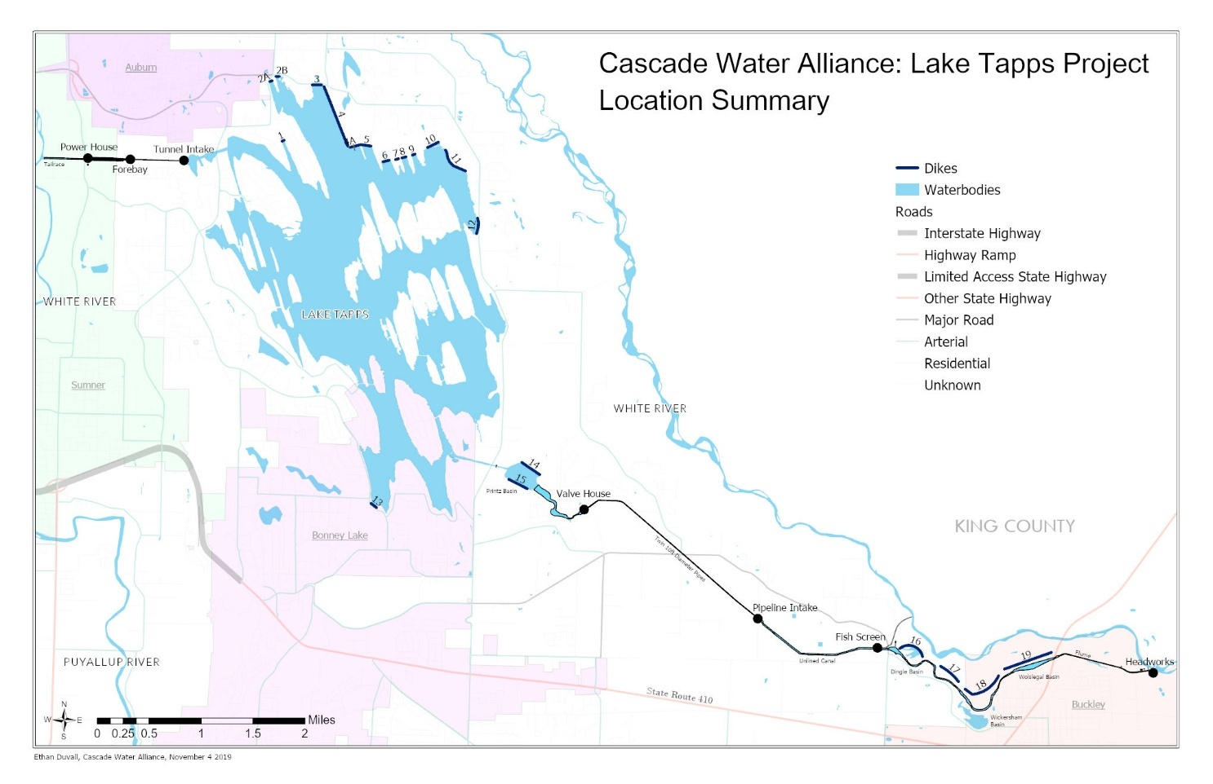

**RFEI QUESTIONS –** PLEASE NOTE, RESPONDENTS ARE ENCOURAGED TO RESPOND TO ALL QUESTIONS COMPLETELY, BUT MAY SUBMIT PARTIAL RESPONSES IF DESIRED.

**Approach to Delivering Scope of Services:**

1. Current practice is for Cascade’s O&M contractor to provide operations, preventative maintenance, and minor repair of the Project’s facilities. All public works subject to public bidding on the Project facilities are the responsibility of Cascade. Cascade estimates that approximately 30% of the current contract effort is expended with facility operations and the balance with preventative maintenance.
   * + 1. While Cascade recognizes the legal requirements associated with competitive bidding of public works projects, please comment on the extent to which your firm would be willing to accept capital maintenance responsibility for the Project facilities, whether on a self-perform basis or in a construction management capacity.
       2. Do you view job order contracting, as authorized under RCW 39.10.420, as a viable means of addressing the capital maintenance needs of the Project? If so, please share any thoughts you may have as to how such contracting could be coordinated with the overall scope of services under the Contract.
       3. If Respondent is a construction contractor, would your firm be interested and have capacity to also provide operational services or would you seek to team with an operational services provider?
2. The Project requires significant seasonal vegetation management for fire prevention, trespass management, and dike inspection. This work is currently completed directly by the O&M contractor with available staff resources allocated up to 70-90% toward vegetation management from May through September.
   * + 1. Are Respondents interested in providing vegetation management as part of the O&M for the Project, or would Respondents prefer Cascade remove these services from the scope of work?
       2. If vegetation management services remain in the scope, would Respondent self-perform or sub-out these services to a third party, including equipment (small and large equipment and seasonal labor resources)?
3. Cascade and the current O&M contractor share responsibilities for security services including trespass management.
4. Are Respondents interested in providing security services and trespass management as part of the scope of services under the operations and maintenance contract? If so, would Respondent self-perform or sub-out these services to a third party?
5. Cascade currently has an O&M contractor performing the indicated scope of services. Transitioning to a new contractor is a possibility. As a result, it will be important to understand how to transition seamlessly.
6. What information or support would you need from Cascade to facilitate a successful handoff?
7. What would you view as a reasonable transition period to assume responsibility for O&M under the new Contract? Would you view a training period with assistance from the current O&M contractor as a necessary component of the transition?
8. A Project O&M manual has been developed with the current O&M contractor to guide the performance of the O&M services for the Project. Please comment on how you would approach adoption of the current O&M manual, including whether you would view compliance with the current O&M manual as a limitation on performance responsibility and whether you would recommend that the new O&M contractor be permitted or required to develop its own O&M manual.

**Project Resources:**

1. Do you have an example of a work management / asset management program currently being used that is effective and well received by the end users? If so, please briefly describe.
2. Project Equipment: Cascade and the O&M contractor currently jointly source the Project with large and small equipment. Some of the large equipment will need to be replaced over the next one-to-five years.
3. Does the Respondent desire to provide all equipment for the Project including large equipment (civil, vegetation management, heavy transport, vehicles, forklifts, manlifts, demolition equipment, etc.) as well as small tools? If equipment rental is a consideration, how would specialty equipment be procured for time sensitive tasks?

**Contract Terms and Conditions:**

1. Are there specific contract structures (e.g., incentive-based, performance-based) that your firm finds most effective in similar projects? What types of risk-sharing mechanisms would make this opportunity more attractive to your firm?
2. Please describe your preferred compensation structure for the performance of the O&M services. To what extent do you believe the O&M services can be priced on a periodic, fixed fee basis?
3. Are there opportunities to establish performance guarantees for the O&M services? Please provide any comments you may have on how best to ensure high quality performance, including any incentive/disincentive regime you think would be appropriate for the O&M services.
4. Please indicate what you would view as the optimal term of the new Contract and explain why.

**Other Considerations & Industry Recommendations:**

1. What risks do you perceive to be associated with the scope of services, and how can Cascade mitigate those concerns to make the Project more attractive to the Respondents?
2. Do Respondents have additional recommendations or considerations for Cascade that will best facilitate the procurement of the new Contract and the delivery of the O&M services?
3. Cascade currently limits the scope of services under this contract to the infrastructure associated with the Project. Would Respondents be interested in providing additional operation and maintenance services in other geographic areas with additional compensation including transmission, storage, chlorination, and booster facilities for public drinking water supply (and / or other misc. non-drinking water-related services)? Respondents should assume facilities are within a 50-mile radius of the Project’s Powerhouse Facility in Sumner Washington.