***SEATTLE PUBLIC UTILITIES***

***Water Supply Update: 8/7/2025***

**SPU has been saying that the regional water system will have sufficient water supply for people and fish for this summer.** **What is meant by “this summer”?**

Summer is June through about mid-September. At mid-September, cooler temperatures start and consumption also starts to decline.

**What are our water supply conditions?**

While we had full reservoirs in May, dry weather and higher than normal consumption has resulted in our reservoirs being below average for this time of year, at about 84% of normal as of 8/6/25. Our reservoir storage is expected to be below average through the end of the drawdown season (typically through October), making us more reliant on October rains showing up than in less dry years. As is typical for a drier-than-average year, we also are preparing to use the pumping plants on the Cedar reservoir to make sure we can access water at lower lake elevations.

**Is this year like 2023 (when we last activated the Water Shortage Contingency Plan)?**

Both 2023 and 2025 had less overall precipitation than average, with very dry and warm summers that resulted in higher-than-average consumption. In 2025, SPU started storing more water sooner in the year, in anticipation of the reduced snow melt to feed the reservoirs. However, reservoir storage trends this summer are tracking closely with 2023.

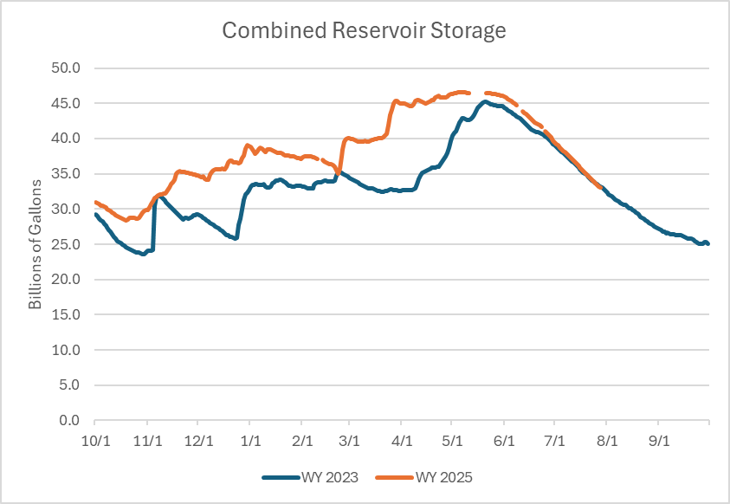

**How are we managing water supply?**

We have a set of water supply levers we can pull that occur before we move into curtailment, and we have been employing those tools.

*These levers have been/are being used*

**How does SPU decide when to activate the Water Shortage Contingency Plan (WSCP)?**

SPU evaluates water supply conditions and forecasts against hydrologic guidelines, which were first developed in 2023. The guidelines consider current reservoir levels/storage volume​, forecasted reservoir elevations (Hydrologic/HFAM modeling), the phase of reservoir management (e.g., refill, drawdown, flood management​) and combined versus individual reservoir conditions​.

As mentioned, this hydrologic guideline was first used in 2023 and SPU is evaluating it further.

Reminder on the 2023 WSCP timing:

• July 5: State announced drought advisory (Statewide)

• July 24: State announced drought emergency (12 watersheds)

• Sept 8: SPU activated our WSCP plan (at Advisory)

• Sept 21: SPU moved to Voluntary Phase

• Dec 11: SPU exited WSCP

Actual Lowest Reservoir levels in 2023:

Cedar: 1540 ft on November 3

Tolt: 1719 ft November 2

**Do you expect to activate the WSCP in 2025?**

We currently don’t meet the trigger points identified in the hydrologic guideline above. Reservoir storage as of 8/6/25 is at 84% and the modeling forecasts completed in early August do not forecast that the reservoir levels will hit the lower limits on the Cedar or Tolt in the next 3 months. Modeling forecasts are updated every 2 weeks.

That said, we are concerned about continuing dry conditions and our heightened reliance on sufficient rain occurring this October.

We are discussing the possibility of “soft messaging” around this concern to alert customers and remind them to use water wisely, while not asking for curtailment outright. We would welcome any thoughts you/your team may have on that front.